QUERY
Query for:
- Total revenue
- Average order value
- Total pizza sold
- Total orders
- Average pizza per order

SELECT
SUM(total_price) AS Total_Revenue,
SUM(total_price) / COUNT(DISTINCT order_id) AS Average_Order_Value,
SUM(quantity) AS Total_Pizza_Sold,
COUNT(DISTINCT order_id) AS Total_Orders,
CAST(CAST(SUM(quantity) AS DECIMAL(10,2)) /
CAST(COUNT(DISTINCT order_id) AS DECIMAL(10,2)) AS DECIMAL(10)) AS Avg_Pizzas_Per_Order
FROM (
SELECT DISTINCT * FROM pizza_sales
) AS Clean_Pizza_Sales;

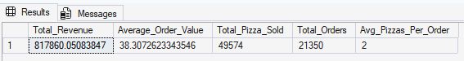

Query for daily sales trends
SELECT
DATENAME(DW, order_date) AS Day_of_Week,
COUNT(DISTINCT order_id) AS Total_Orders
FROM (
SELECT DISTINCT * FROM pizza_sales
) AS Clean_Data
GROUP BY DATENAME(DW, order_date)
ORDER BY Total_Orders DESC;

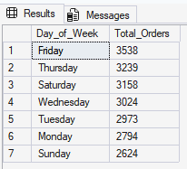

Query for hourly trends for total orders
SELECT
DATEPART(HOUR, order_time) AS Order_Hour,
COUNT(DISTINCT order_id) AS Total_Orders
FROM (
SELECT DISTINCT * FROM pizza_sales
) AS Clean_Data
GROUP BY DATEPART(HOUR, order_time)
ORDER BY Order_Hour;
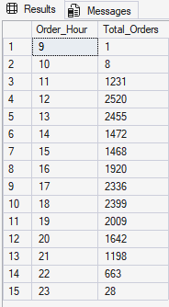

PERCENTAGE OF SALE BY CATEGORY

Query for percentage of sales by pizza category
SELECT
pizza_category,
CAST(SUM(total_price) AS DECIMAL(10,2)) AS Total_Revenue,
CAST(SUM(total_price) * 100 / (SELECT SUM(total_price) FROM (SELECT DISTINCT * FROM pizza_sales) AS X) AS DECIMAL(10,2)) AS PCT
FROM (
SELECT DISTINCT * FROM pizza_sales
) AS Clean_Pizza_Sales
GROUP BY pizza_category
ORDER BY PCT DESC;

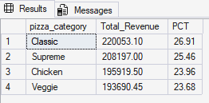

Query for percentage of sales by pizza category (monthly)
SELECT
DATENAME(MONTH, order_date) AS Month_Name,
pizza_category,
CAST(SUM(total_price) AS DECIMAL(10,2)) AS Monthly_Category_Revenue,
CAST(SUM(total_price) * 100 /
SUM(SUM(total_price)) OVER(PARTITION BY DATENAME(MONTH, order_date))
AS DECIMAL(10,2)) AS PCT_of_Monthly_Sales
FROM (
SELECT DISTINCT * FROM pizza_sales
) AS Clean_Data
GROUP BY DATENAME(MONTH, order_date), pizza_category
ORDER BY MONTH(MIN(order_date)), PCT_of_Monthly_Sales DESC;

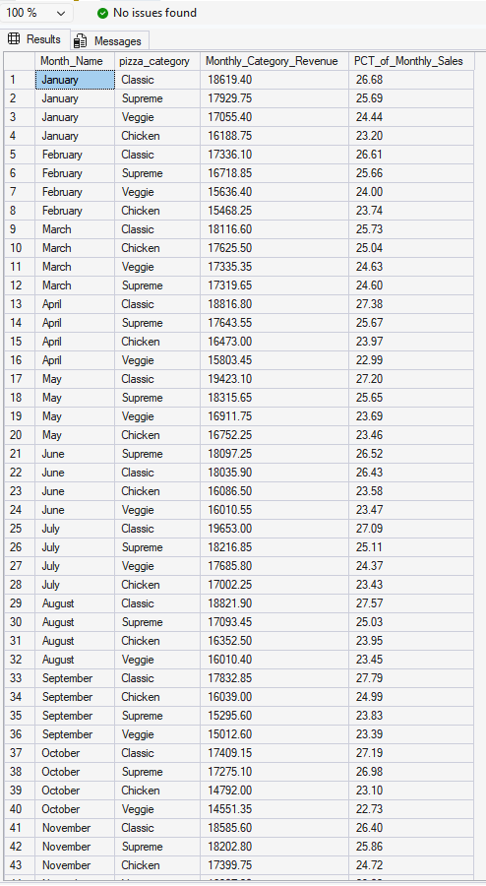

Query for percentage of sales by pizza category (Quarterly)
SELECT
DATEPART(QUARTER, order_date) AS Quarter_Number,
pizza_category,
CAST(SUM(total_price) AS DECIMAL(10,2)) AS Quarterly_Category_Revenue,
CAST(SUM(total_price) * 100 /
SUM(SUM(total_price)) OVER(PARTITION BY DATEPART(QUARTER, order_date))
AS DECIMAL(10,2)) AS PCT_of_Quarterly_Sales
FROM (
SELECT DISTINCT * FROM pizza_sales
) AS Clean_Data
GROUP BY DATEPART(QUARTER, order_date), pizza_category
ORDER BY Quarter_Number, PCT_of_Quarterly_Sales DESC;

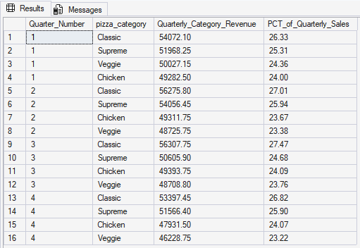
Query for percentage of sales by pizza category (Weekly)
SELECT
DATEPART(WEEK, order_date) AS Week_Number,
pizza_category,
CAST(SUM(total_price) AS DECIMAL(10,2)) AS Weekly_Category_Revenue,
CAST(SUM(total_price) * 100 /
SUM(SUM(total_price)) OVER(PARTITION BY DATEPART(WEEK, order_date))
AS DECIMAL(10,2)) AS PCT_of_Weekly_Sales
FROM (
SELECT DISTINCT * FROM pizza_sales
) AS Clean_Data
GROUP BY DATEPART(WEEK, order_date), pizza_category
ORDER BY Week_Number, PCT_of_Weekly_Sales DESC;
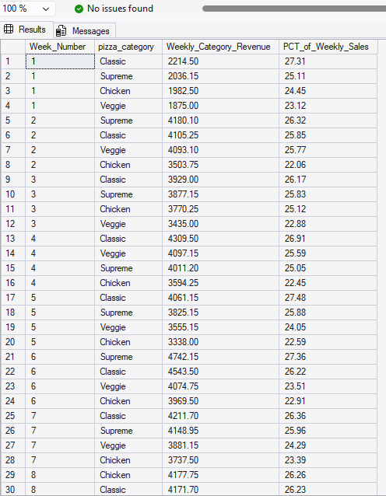

Query for percentage of sales by pizza size
SELECT
pizza_size,
CAST(SUM(total_price) AS DECIMAL(10,2)) AS Total_Revenue,
CAST(SUM(total_price) * 100 / (SELECT SUM(total_price) FROM (SELECT DISTINCT * FROM pizza_sales) AS X) AS DECIMAL(10,2)) AS PCT_of_Total_Sales
FROM (
SELECT DISTINCT * FROM pizza_sales
) AS Clean_Data
GROUP BY pizza_size
ORDER BY PCT_of_Total_Sales DESC;
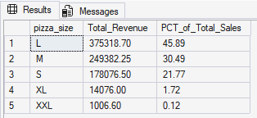

Query for total pizzas sold by pizza category
SELECT
pizza_category,
SUM(quantity) AS Total_Pizzas_Sold
FROM (
SELECT DISTINCT * FROM pizza_sales
) AS Clean_Data
GROUP BY pizza_category
ORDER BY Total_Pizzas_Sold DESC;
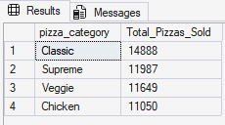

Query for top 5 best sellers by total pizzas sold
SELECT TOP 5
pizza_name,
SUM(quantity) AS Total_Pizzas_Sold
FROM (
SELECT DISTINCT * FROM pizza_sales
) AS Clean_Data
GROUP BY pizza_name
ORDER BY Total_Pizzas_Sold DESC;

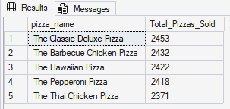

Query for bottom 5 worst sellers by total pizza sold
SELECT TOP 5
pizza_name,
SUM(quantity) AS Total_Pizzas_Sold
FROM (
SELECT DISTINCT * FROM pizza_sales
) AS Clean_Data
GROUP BY pizza_name
ORDER BY Total_Pizzas_Sold ASC;
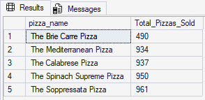

Note
To filter for monthly, quarterly and weekly swap:
- Monthly: WHERE MONTH(order_date) = 1 (for January)
- Quarterly: WHERE DATEPART(QUARTER, order_date) = 1 (for Q1)
- Weekly: WHERE DATEPART(WEEK, order_date) = 1 (for Week 1)
Example
Percentage of Sales by Pizza Size
SELECT
pizza_size,
CAST(SUM(total_price) AS DECIMAL(10,2)) AS Total_Revenue,
CAST(SUM(total_price) * 100 / (
SELECT SUM(total_price)
FROM (SELECT DISTINCT * FROM pizza_sales) AS X
WHERE MONTH(order_date) = 1 -- Change to Quarter or Week here
) AS DECIMAL(10,2)) AS PCT
FROM (
SELECT DISTINCT * FROM pizza_sales
) AS Clean_Data
WHERE MONTH(order_date) = 1 -- Change to Quarter or Week here
GROUP BY pizza_size
ORDER BY PCT DESC;

Total Pizzas Sold by Pizza Category

SELECT
pizza_category,
SUM(quantity) AS Total_Pizzas_Sold
FROM (
SELECT DISTINCT * FROM pizza_sales
) AS Clean_Data
WHERE MONTH(order_date) = 1 -- Filter: Change to Quarter or Week
GROUP BY pizza_category
ORDER BY Total_Pizzas_Sold DESC;

Top 5 Best Sellers (by Quantity)
SELECT TOP 5
pizza_name,
SUM(quantity) AS Total_Pizzas_Sold
FROM (
SELECT DISTINCT * FROM pizza_sales
) AS Clean_Data
WHERE MONTH(order_date) = 1 -- Filter: Change to Quarter or Week
GROUP BY pizza_name
ORDER BY Total_Pizzas_Sold DESC;

Bottom 5 Worst Sellers (by Quantity)
SELECT TOP 5
pizza_name,
SUM(quantity) AS Total_Pizzas_Sold
FROM (
SELECT DISTINCT * FROM pizza_sales
) AS Clean_Data
WHERE MONTH(order_date) = 1 -- Filter: Change to Quarter or Week
GROUP BY pizza_name
ORDER BY Total_Pizzas_Sold ASC;

